Duval County Beach Renourishment Project – Summer 2011

The Jacksonville Beaches will be renourished with sand this summer through a project to be constructed by the U. S. Army Corps of Engineers. Beach renourishment occurs about every five to six years to maintain our beaches as part of the Duval County Federal Shore Protection Project. The project is scheduled to place approximately 735,000 cubic yards of sand along a total of about six miles of shoreline, in two separate reaches (see Figure A):
- The north placement area will include 1.7 miles of shoreline from about 350-ft south of 19th Street in Atlantic Beach to Lemon Street in Neptune Beach.
- The south placement area will include 4.2 miles of shoreline from South Street (one block south of Florida Avenue) through all of Jacksonville Beach to the St. Johns County line.
Most of Neptune Beach will not be included in the sand placement because this beach exhibits very little erosion relative to the project’s design requirements, and as sand placed along the adjacent Atlantic and Jacksonville Beaches ultimately drifts into the Neptune Beach area.

The beach renourishment sand will be dredged from the seabed at the project’s offshore sand borrow area located about 6.7 nautical miles offshore. (See Figure B.) This is the same general borrow area that has been used for the previous nourishment projects since 1978, and which has rebuilt the beach that we have today. (The project will not use sediment dredged from the St. Johns River Entrance, which resulted in large shells placed upon, and then removed from, south Jacksonville Beach in 2003 during deepening of the river-inlet channel.)

It is presently anticipated that dredging and beach construction will commence in late June (around June 25 or 30) and will be completed by mid-August 2011. The actual construction schedule may be delayed slightly, depending upon the need for the dredge equipment to remain working on the Mississippi River. This requirement is still being determined by the U. S. Army Corps of Engineers. If the June 20-25 start date holds, and favorable seas permit, then it is anticipated that the southern (Jacksonville Beach) segment will be completed by the end of July, and the northern (Atlantic Beach) segment will be constructed during the first two weeks of August, 2011. This schedule is subject to change.

Beach construction equipment – including pipes, bulldozers, trailers, and survey equipment – is scheduled to arrive beginning around June 13. Most of this equipment will be delivered to the beach at 16th Street South in Jacksonville Beach. The 16th Avenue South street end and beach access at this location will be closed for most, or all, of the construction period; through mid- to late-August. A very unusual vehicle that will arrive is the “CRAB”. This is a beach surveying device that drives across the beach and into the sea to measure the elevation of the beach before and after the renourishment sand is placed (see Figure C.)

Beach fill construction is presently expected to begin at the south end of Jacksonville Beach and progress northward. Initial sand placement will begin with the first pipeline “landing” around 36th Avenue South, progressing southward to the County Line, and then northward from 36th Avenue. The dredging contractor will establish four or five pipeline “landings” upon the shore in Jacksonville Beach, and two “landings” in Atlantic Beach, each separated by about 5000-feet. Beach sand will be placed through the pipeline toward the south, and then toward the north, from each “landing” site where the dredging pipeline comes ashore from the sea.

Construction will progress along the beach at a rate of between about 500 feet and 700 feet per day. At any given time, about 1200-feet of beachfront (or about 3 city blocks) will be temporarily closed for public access in the immediate vicinity of the sand-discharge area, for reasons of safety. The area of temporary beach closure will be marked by plastic fences. The restricted area will move along the beach each day with the progress of the construction. So, the beach at your residence or street-end access may be closed for between 1 and 3 days at some point during the construction activity if you are located within the project area. But, the beach adjacent to the closed area, a block or two to the north or south, will be open for access. For your safety, it is very important not to enter the closed-beach area because of the busy activity of heavy equipment (bulldozers and other trucks) and the high-pressure discharge of sand and water to the shoreline.

Once beach construction begins, the progress of the work – and the projected schedule of progress for the next seven days – will be updated and posted on this website every week.

The construction will be conducted seven days a week, 24-hours per day. During both day and night, the bulldozers and other heavy trucks must use beepers when they are backing up. These beepers are an important safety measure for the workers, required by OSHA, and they cannot be turned off or lowered in volume. But like the short-term beach closures, the noise of the beepers, trucks and generators is a temporary inconvenience that passes along the shoreline within a day or two.

The 2011 beach renourishment will widen the beach berm by between 20 and 80 feet in width, and raise the elevation of the intertidal beach by about 3 to 5 feet. The amount of increased beach width and height will vary along the shoreline. The sand placement will not affect, or change, the dunes. (See Figure D.) Within a few weeks after construction, the seaward edge of the placed sand will be worked by waves and tides. The sand will begin to move offshore to fill the submerged “base” of the active beach out to 10 or 20 feet of water depth. While it thus often appears that the beach is eroding away immediately after placement, this “equilibration” of the sand is instead a natural process of the beach renourishment construction. Simply stated, it is more economical and efficient for waves and currents to distribute the placed sand across the entire beach profile than for the construction equipment to try to place the sand underwater and across the sand bars.

The beach renourishment will be constructed by one or more “hopper dredges”. (See Figure E.) A hopper dredge removes sand from the offshore borrow area and stores it aboard the vessel’s hold (usually up to between 2000 and 4000 cubic yards), travels to within about 3000 feet of the shoreline, hooks up to a temporary pipeline, and then pumps the sand through a steel pipeline to the beach, mixed with seawater. The pipeline runs along the beach to the point where the sand and water are discharged upon the beach. (See Figure F.) Bulldozers move and shape the sand that is discharged from the pipeline. Once the required amount of sand is placed, more pipe is added and the activity continues further along the shoreline. At any given time, there may be several thousand feet of pipeline laid in a line along the beach. It usually takes about 4 hours between each return of the hopper dredge from the offshore sand borrow area to the shoreline. Pumping each load of sand from the dredge typically takes between about 45 minutes and an hour.

Temporary sand ramps will be constructed over the pipeline (which is usually about 2-1/2 feet in diameter) every few hundred feet along the shoreline so that the public can cross over the pipe and access the sea -- once the construction has passed alongshore and the beach is reopened. After a week or two, the entire pipeline will be removed to another location, further north along the beach.

Initially, the sand placed to the beach will appear dark. After a few days or weeks, the sand will lighten in color and become almost indistinguishable from the existing beach sand. In fact, most of the sand that exists along our beaches – since 1978 -- is from the same general offshore area from which this project will dredge and place the sand.

Before and during construction, the beach is monitored every day for sea turtle and shorebird nesting activities. Sea turtle nests that might be impacted by the construction are relocated to the beach (near Hanna Park) away from the project where the eggs can hatch and the new turtles can enter the sea. Any shorebird nests are marked and avoided. After the sand placement is completed (and again in early Spring for the next few years), the beach will be “tilled” to ensure it is suitably “loose”, or soft, for marine turtle nesting, per the project’s environmental permit requirements.

Temporary vibration monitors will be placed at various locations along the shorefront a few weeks before, and during, construction. These monitoring devices, housed in metal “dog-house” size boxes, help ensure that the movement of the construction equipment does not damage upland structures. As evidenced from prior projects, such damage is not likely from the beach renourishment -- principally because the construction activity is on the far seaward side of the dunes, away from the upland development.

The construction contractor for the 2011 renourishment is Great Lakes Dredge and Dock Company of Oak Brook, Illinois. The construction is contracted and managed by the U. S. Army Corps of Engineers, Jacksonville District. The project’s local sponsor is the City of Jacksonville. The construction cost is $11.8 million, of which the Corps of Engineers provides $7.3M (61.6%), the State of Florida provides $2.1M (18.1%) and the City of Jacksonville provides $2.4M (20.3%). The cost-share by the State of Florida is made possible through the public beach access and parking that has been developed along the Jacksonville Beaches.

The Duval County federal beach nourishment project was initially constructed in 1978-80. Since then, there have been four principal renourishments (1985-87, 1991, 1995, and 2005) in addition to periodic placement of maintenance-dredged sand from the St. Johns River Entrance along the Mayport Naval Station and north Hanna Park shorelines. Duval County’s is among the oldest and most successful beach restoration projects in the State of Florida. The requirement to initially restore, and now periodically renourish, our beaches is due in part to the effect of the dredging and jetties at the St. Johns River Entrance, which allow commercial navigation through the Ports of Jacksonville and military access to Mayport Naval Station. Additional historical information about Duval’s ocean shoreline, beach erosion, and restoration can be found in the article on the City web site at www.coab.us.

For other information, questions or concerns regarding the 2011 beach renourishment project, contact Atlantic Beach Public Works at 247-5834.

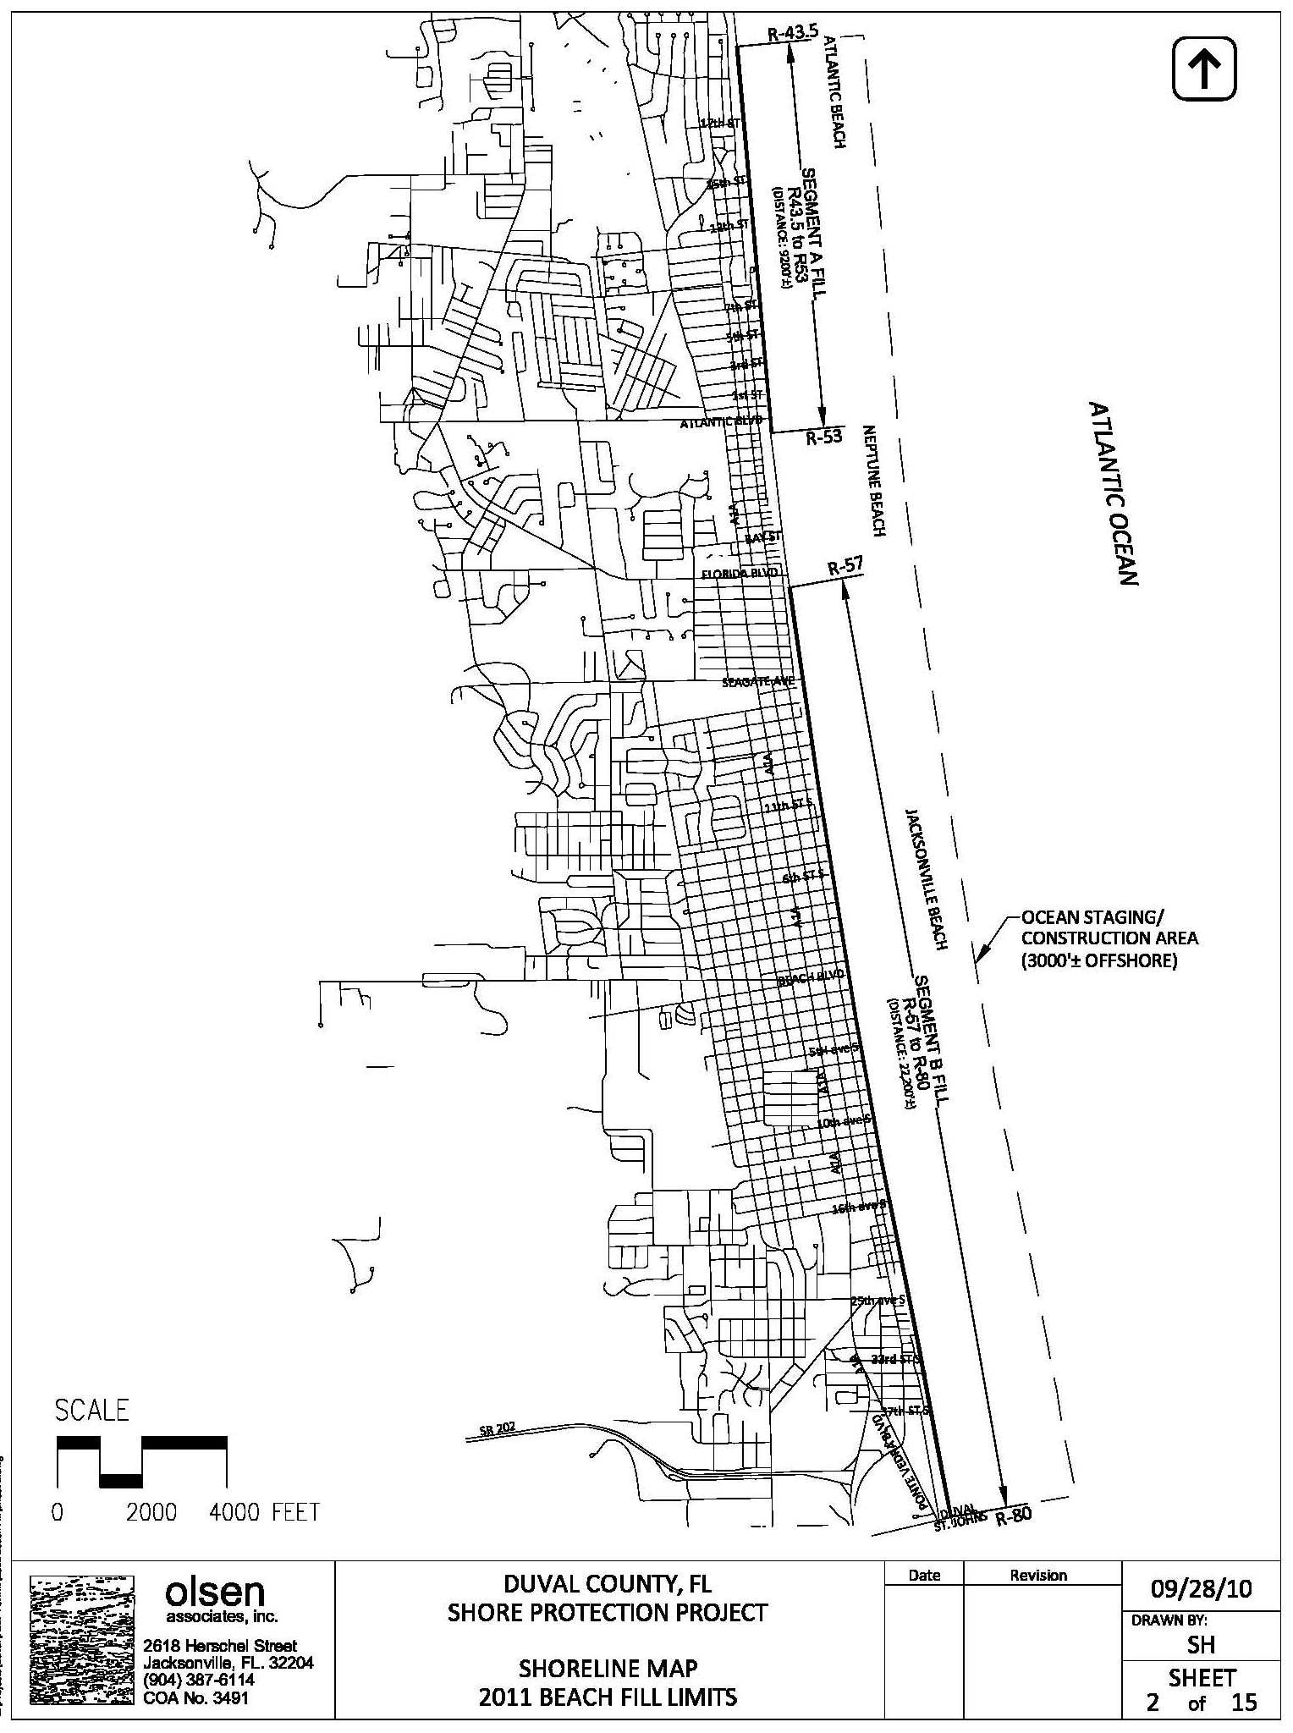
Figure A: Locations of beach renourishment sand placement, Summer 2011.
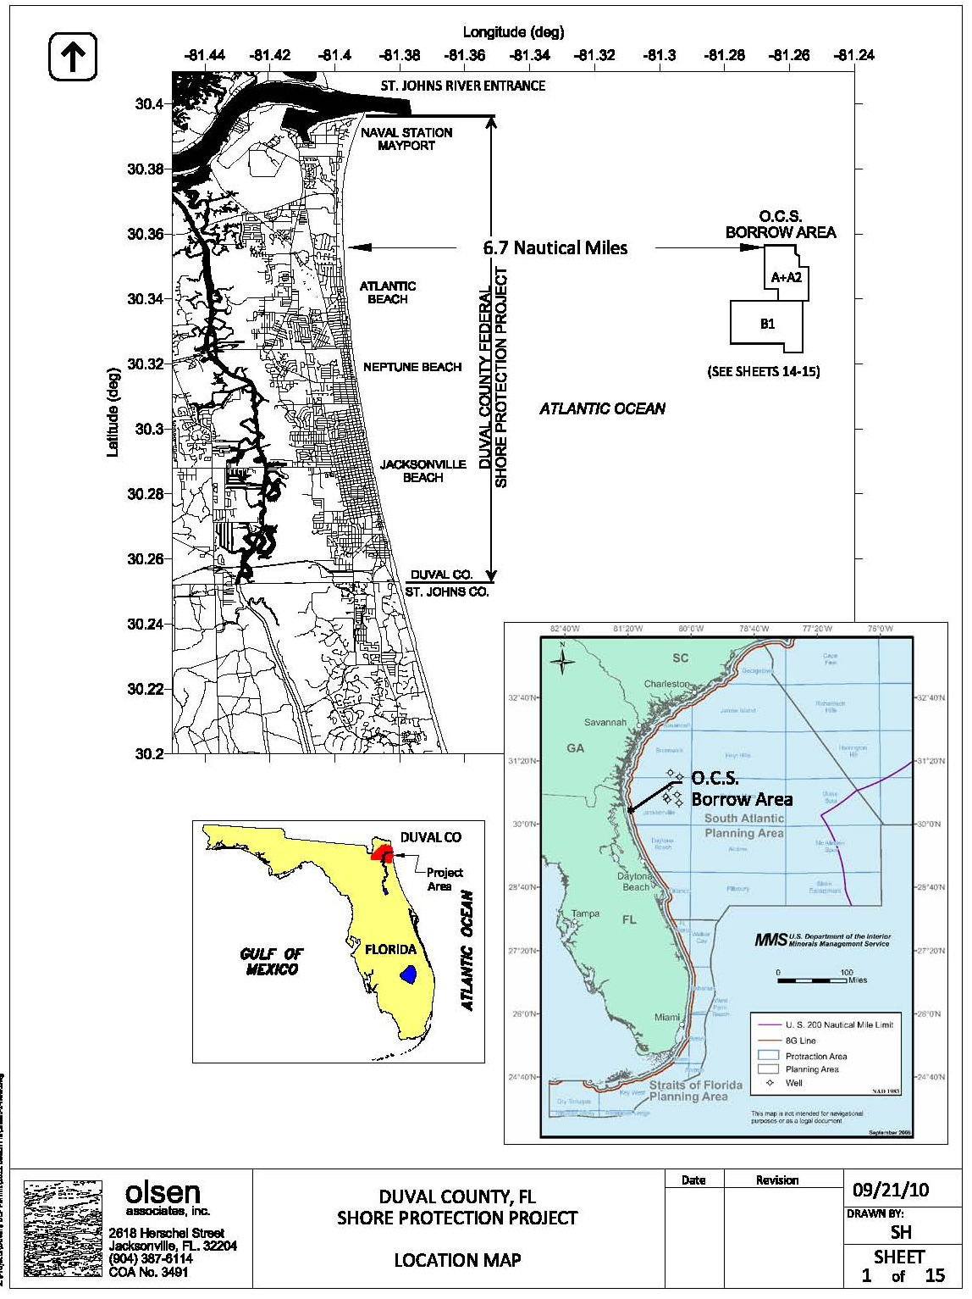
Figure B: Location of offshore sand dredging area to be used for the renourishment project.

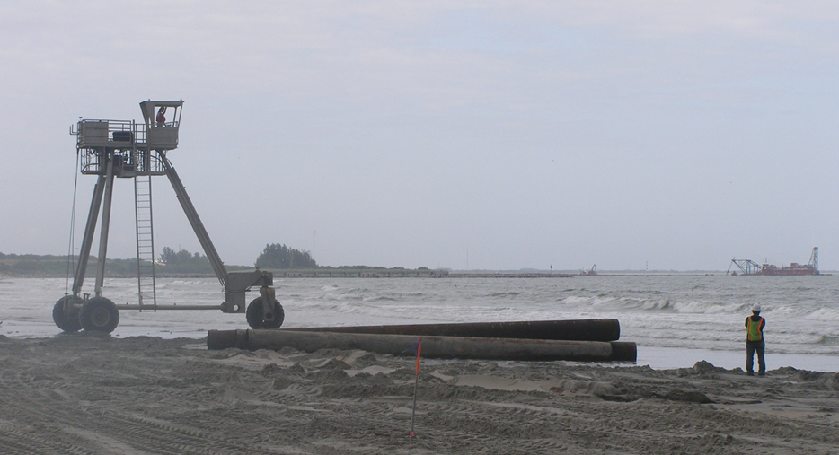
Figure C: The CRAB beach profile survey vehicle.

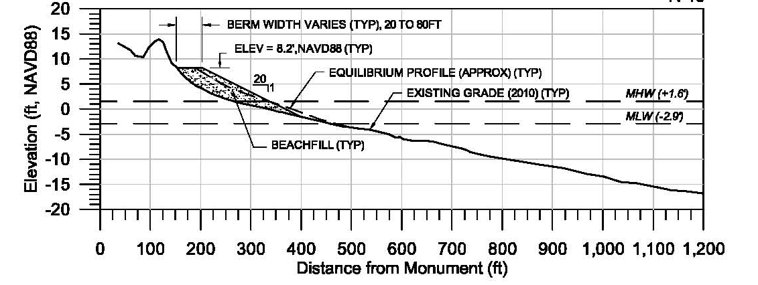

Figure D: Typical beach fill profile to be constructed.
(Note: the vertical scale is exaggerated 10 times the horizontal scale in this illustration.)

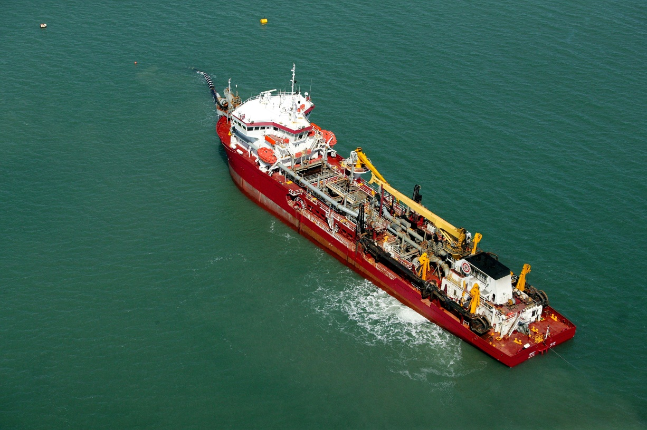
Figure E: The Great Lakes Dredge & Dock Company hopper dredge “Liberty Island” hooked up to a pipeline (black line off the ship’s bow) and pumping sand toward the beach.
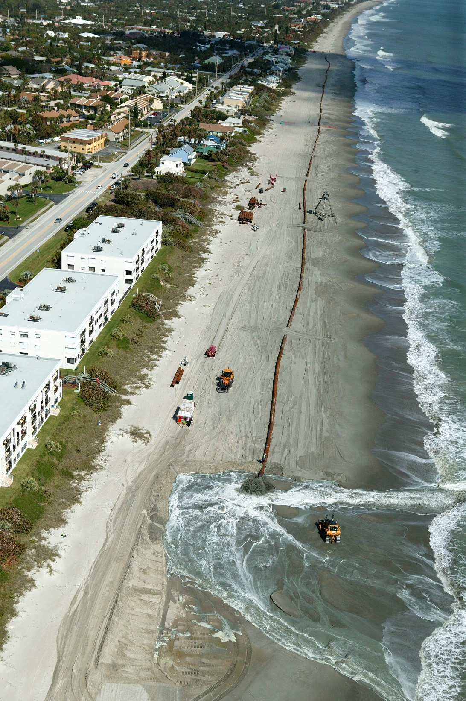
Figure F: Example of renourishment sand being discharged from the pipeline to the beach.

This project synopsis was prepared by Dr. Kevin Bodge, P.E., Olsen Associates, Inc., coastal engineering consultant to the City of Jacksonville for the Duval County beach renourishment project. May 6, 2011.

